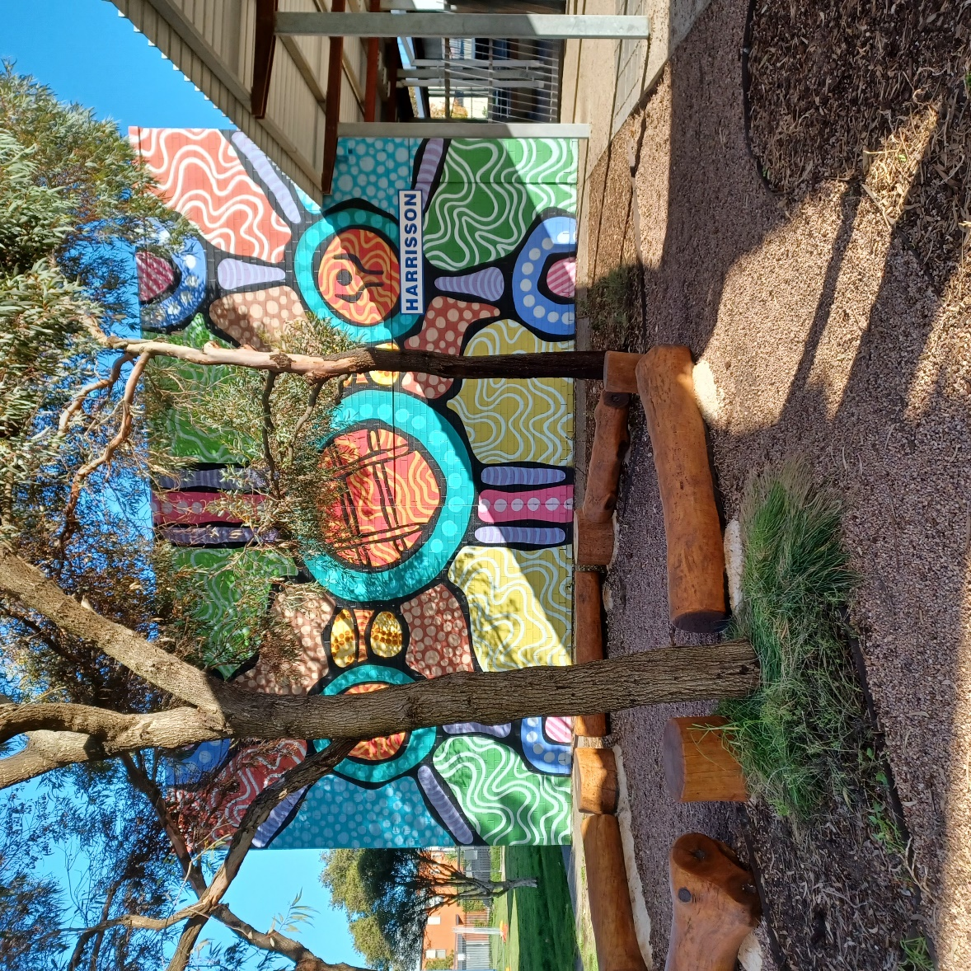

Newsletter

Term 1 Week 1

31st January 2024

|  |
| --- |
|  |
| <https://sway.cloud.microsoft/AvRANtsaBn37ARPG?ref=Link> |
|  |
|  |